Romand Lansangan

**Brainy Business: Utilizing Bayes’ Rule and Decision Trees for Brainet Launch**

APM1134 Summative Assessment 2

May 18, 2025

3rd Year Applied Mathematics (Data Science)

**Problem Motivation**

Charlotte Rothstein and her company *Cerebrosoft* is facing a difficult decision in the face of launching of their new product, Brainret. Although the product is promising, Charlotte is confounded with the competitive market of Silicon Valley, implementing competitive price for their product, and how many Brainret will sell in the first place. The following are the variables to consider:

1. Price – what price should the Brainret be sold?
   1. Low Price (lP) – $30 (for better market share)
   2. Medium Price (mP) – $40 (for balanced between market share and revenues)
   3. High Price (hP) – $50 (for maximizing revenues)
2. Development (Cost) – $800,000
3. Support and Shipping – $50,000 / yr
4. Prior Probabilities
   1. Low Competition (lC) – 0.1
   2. Medium Competion (mC) – 0.70
   3. High Competition (hC) – 0.2
5. sold:
   1. Low Sales (lS) – 50,0000 units
   2. Medium Sales (mS) – 30,000 units
   3. High Sales (hS) – 20,000 units

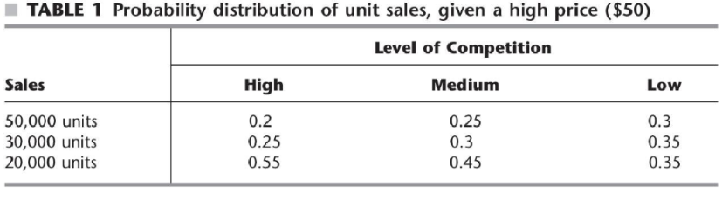

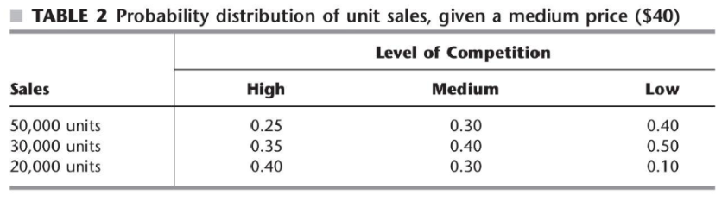

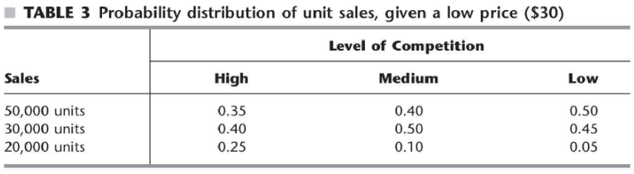

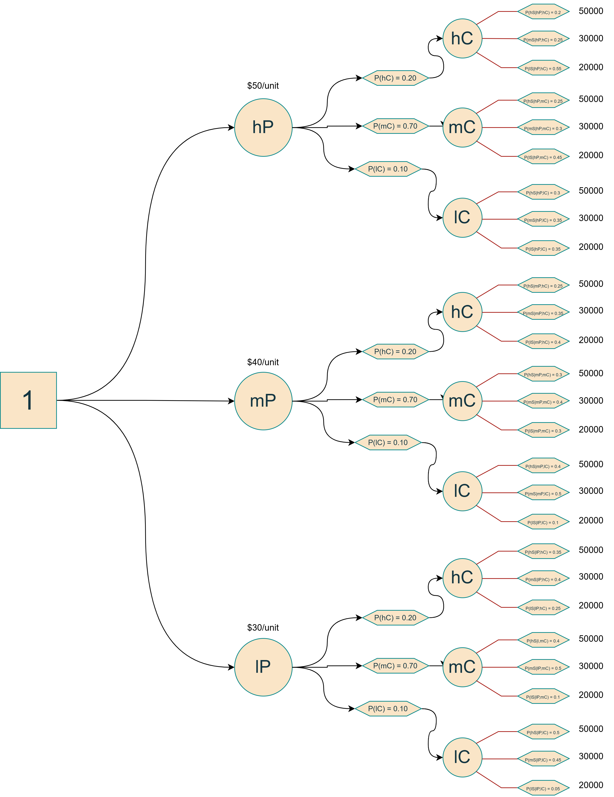

oBJECTIVE:

mAXIMIZE PAYOFF

Where:

PAYOFF = unit Sold * Price

Initial Decision Tree

First Fold

Calculated As follows:

Second Fold

Calculated As follows:

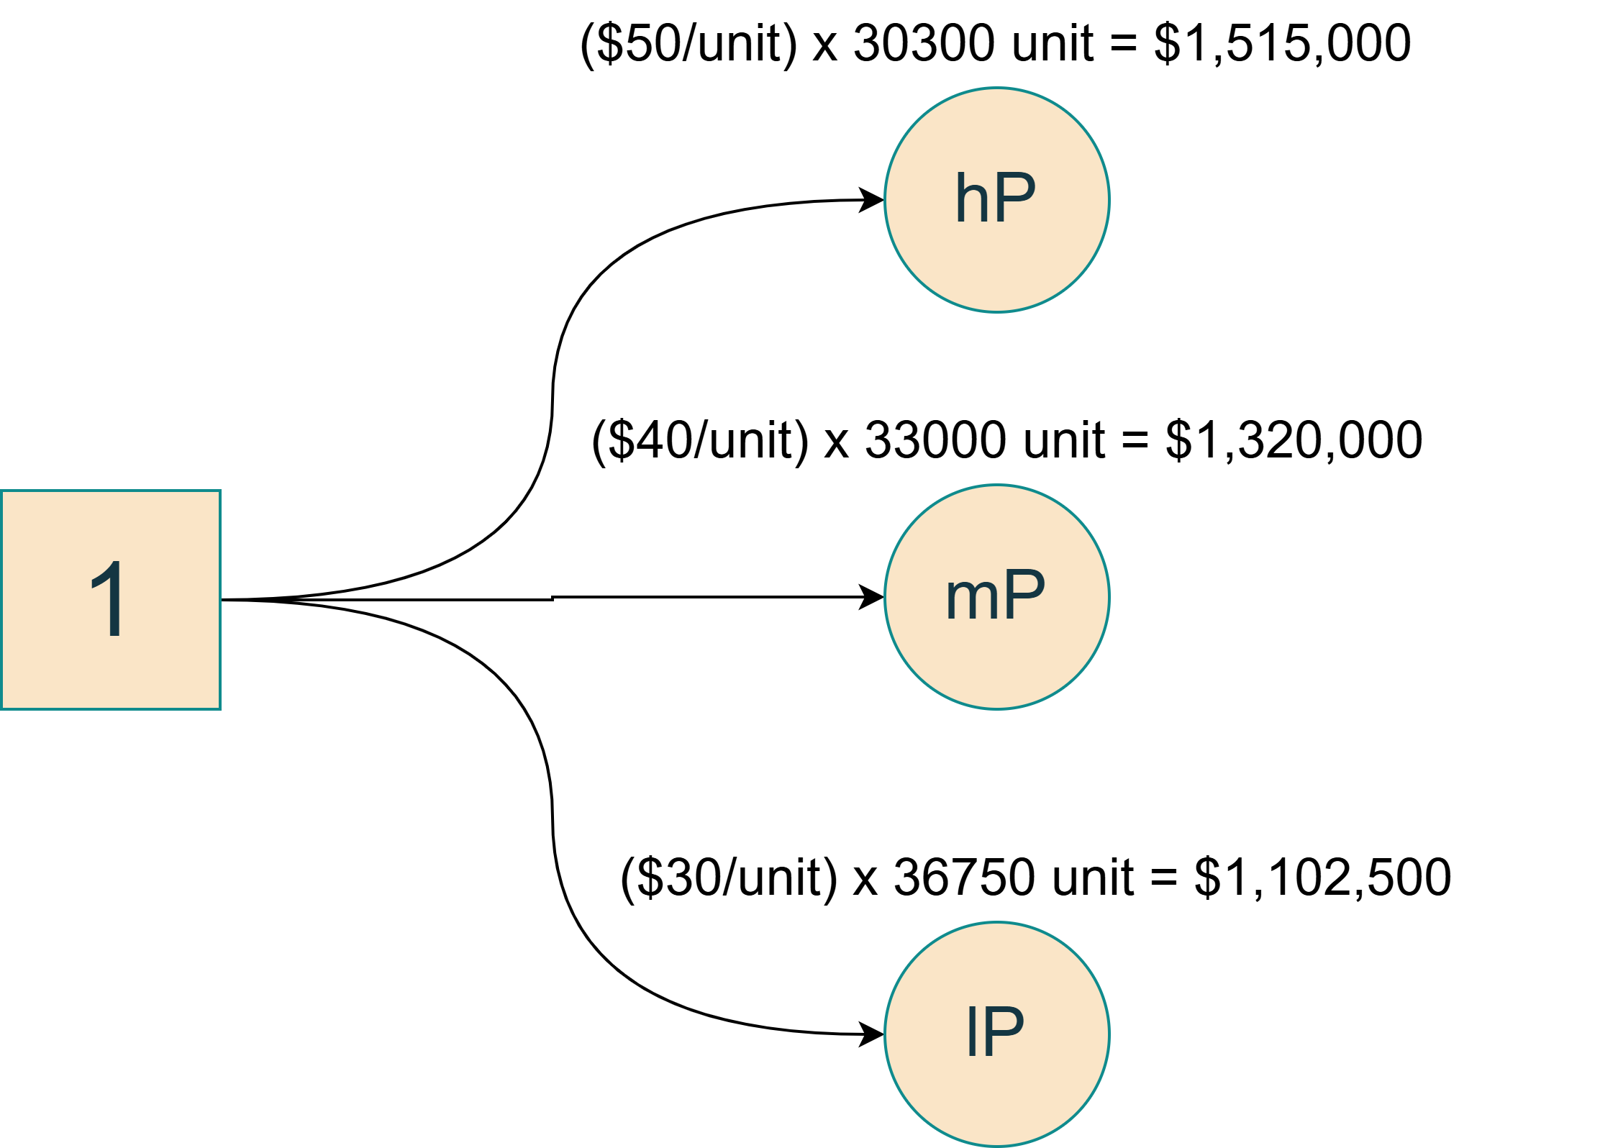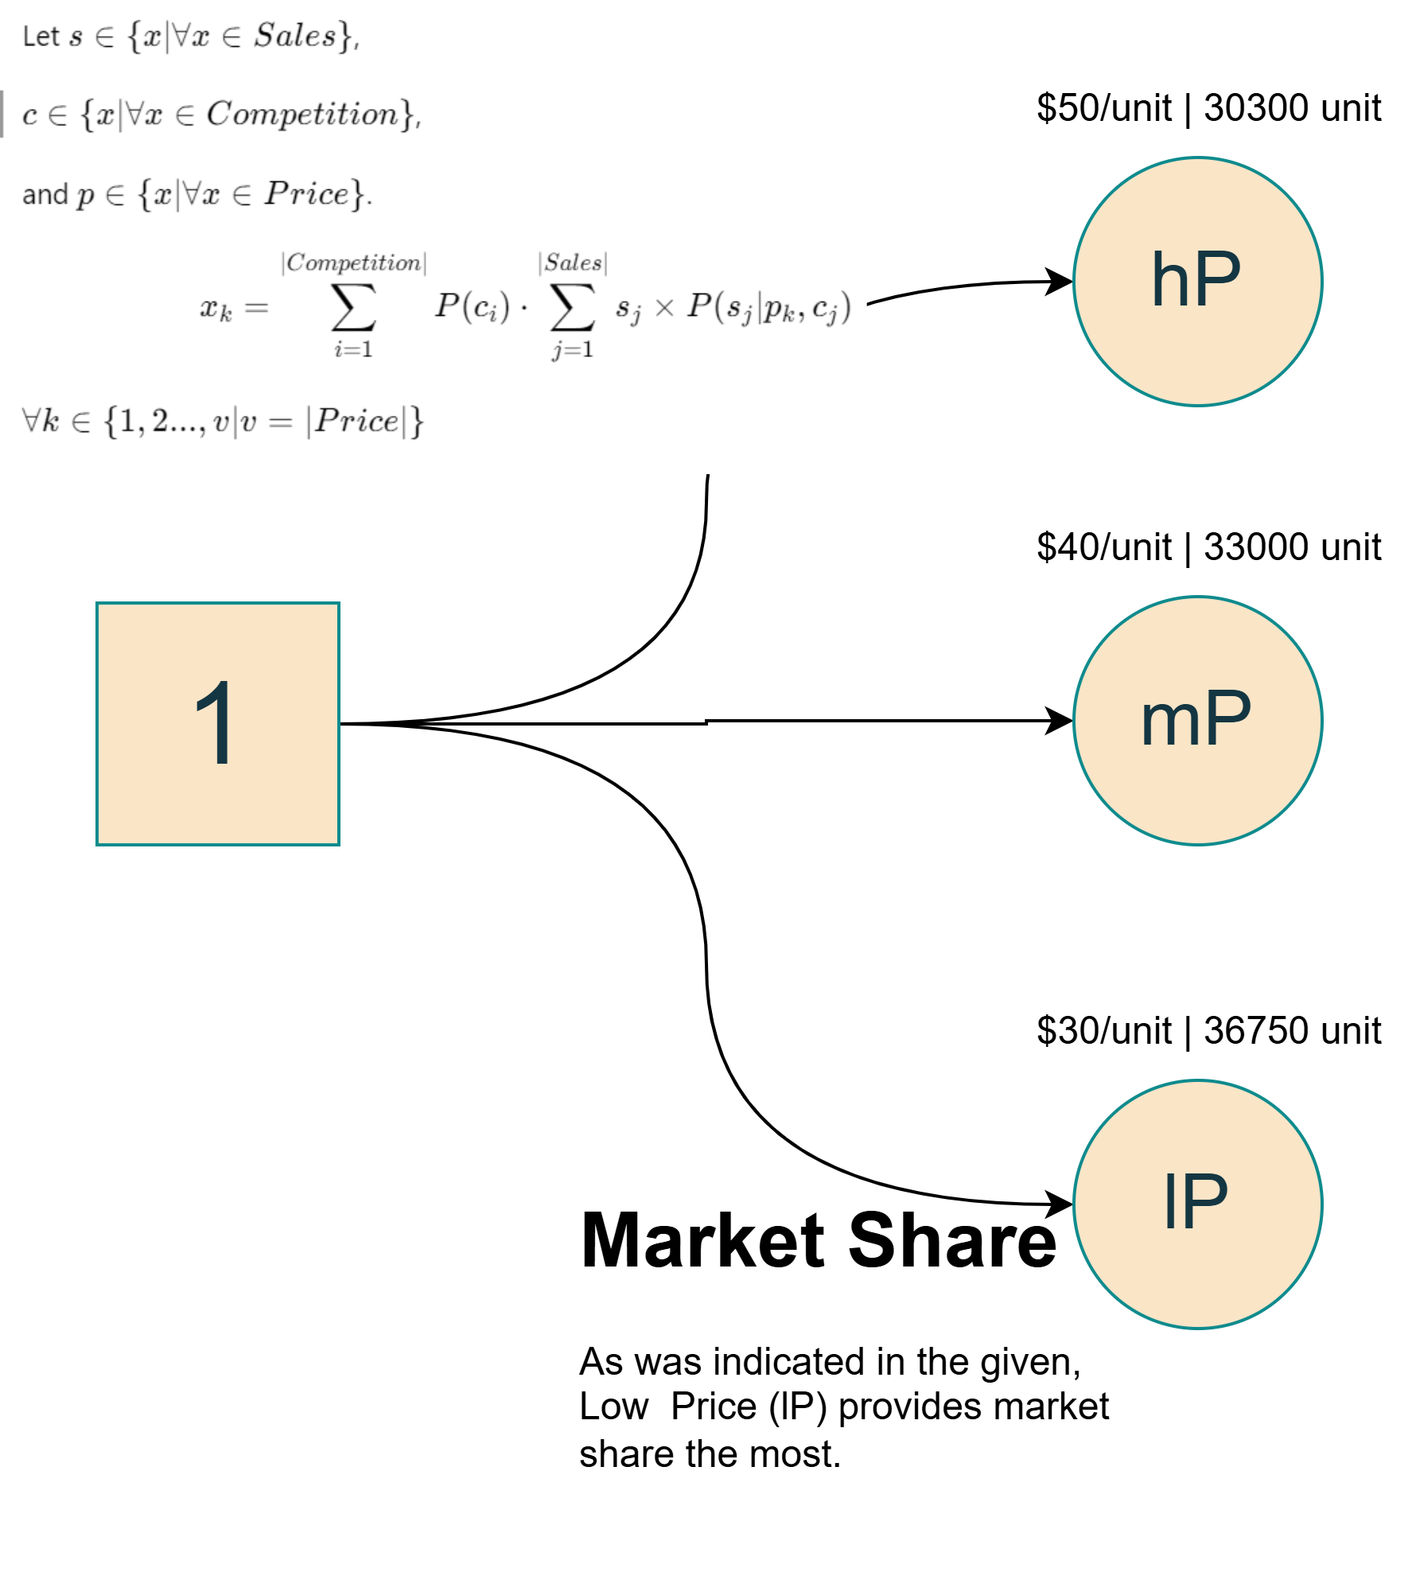

Since hP have the maximum payoff.

**Charlotte should Choose to sell BrainRet at $50 per unit (hP).**

Decision

**Market Research**

The marketing research company offered their services for **$10,000**. They have the following track record:

**Table 4**: Probability Distribution of Prediction Given High Price ($50)

|  |  |  |  |
| --- | --- | --- | --- |
| Predicted **\ Given** | **hC** | **mC** | **lC** |
| P-hC | 0.80 | 0.15 | 0.03 |
| P-mC | 0.15 | 0.80 | 0.07 |
| P-lC | 0.05 | 0.05 | 0.90 |



**Table 5:** Probability Distribution for each Competition.

|  |  |  |
| --- | --- | --- |
| **hC** | **mC** | **lC** |
| 0.20 | 0.70 | 0.10 |



**Table 6**: Joint Probability Distribution of Prediction and Competition Given High Price ($50)

|  |  |  |  |
| --- | --- | --- | --- |
| Predicted **\ Given** | **hC** | **mC** | **lC** |
| P-hC | 0.16 | 0.105 | 0.003 |
| P-mC | 0.03 | 0.560 | 0.007 |
| P-lC | 0.01 | 0.035 | 0.090 |



**Table 7:** Marginal Probability Distribution of Predictions Given High Price ($50)

|  |  |  |
| --- | --- | --- |
| **P-hC** | **P-mC** | **P-lC** |
| 0.268 | 0.597 | 0.135 |



**Table 8**: Probability Distribution of Comptetion Given High Price ($50)

|  |  |  |  |
| --- | --- | --- | --- |
| Competition **\ Given** | **P-hC** | **P-mC** | **P-lC** |
| hC | 0.597015 | 0.050251 | 0.074074 |
| mC | 0.391791 | 0.938023 | 0.259259 |
| lC | 0.011194 | 0.011725 | 0.666667 |



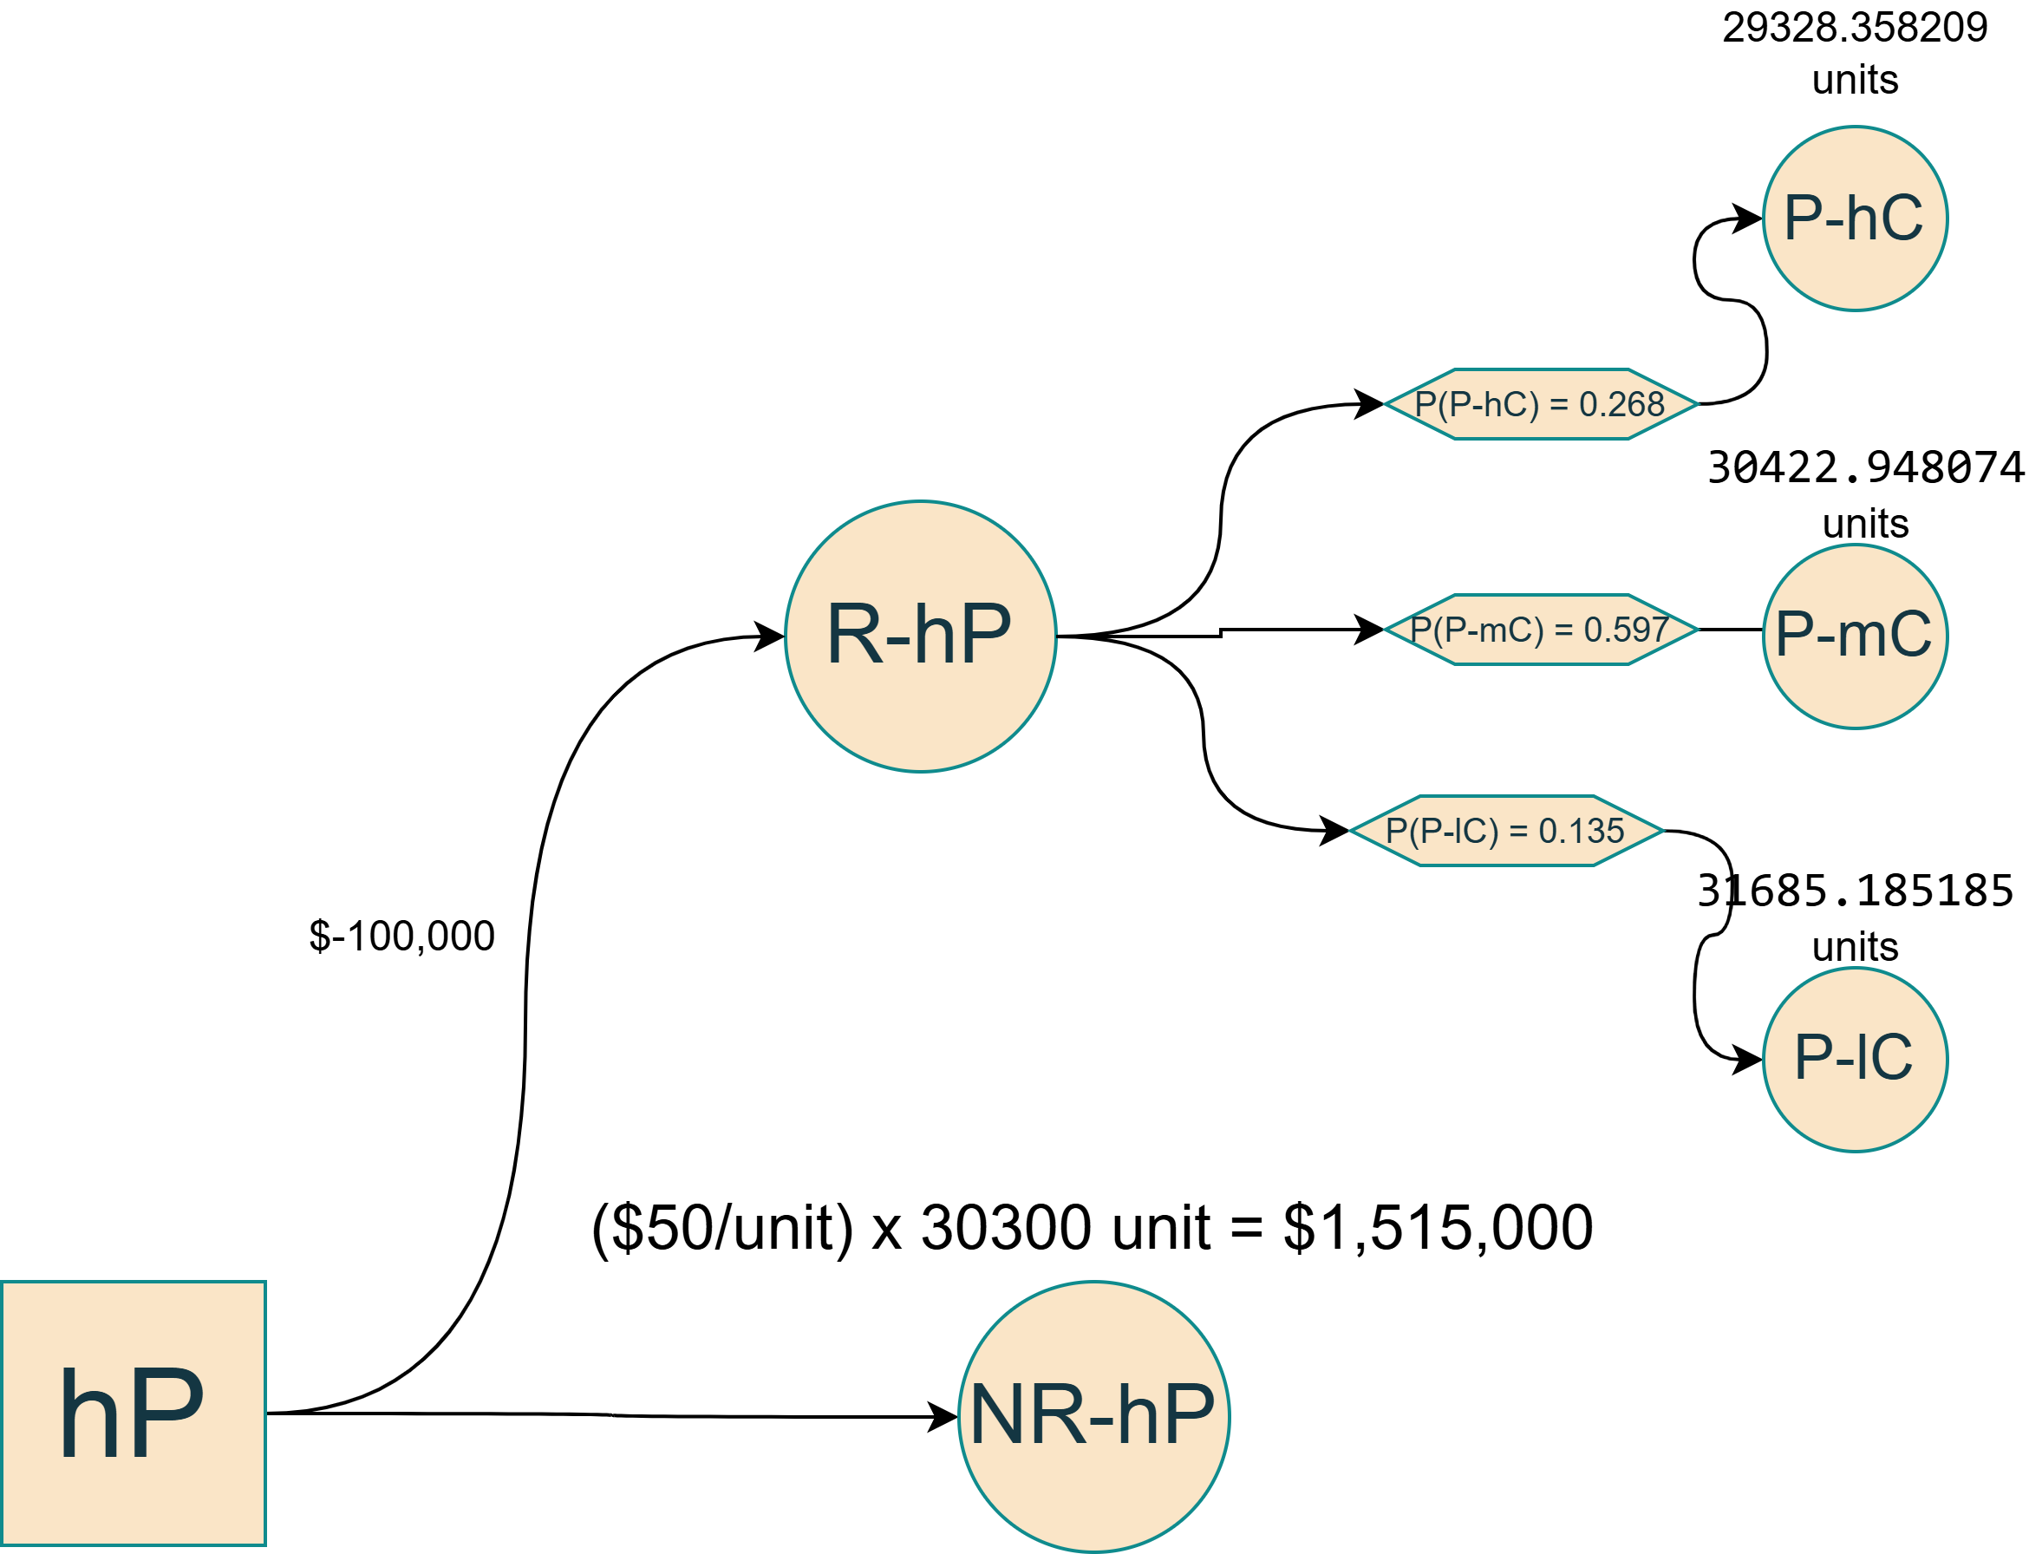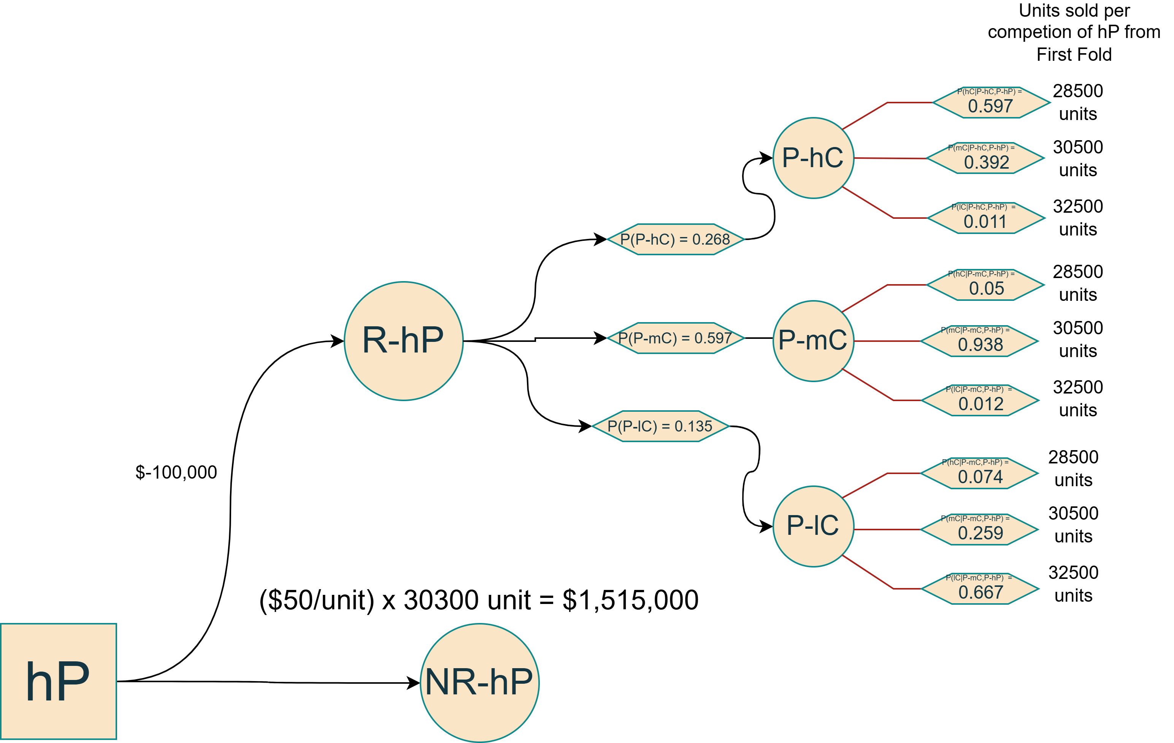

With Research - First Fold

High Price Tree with Research

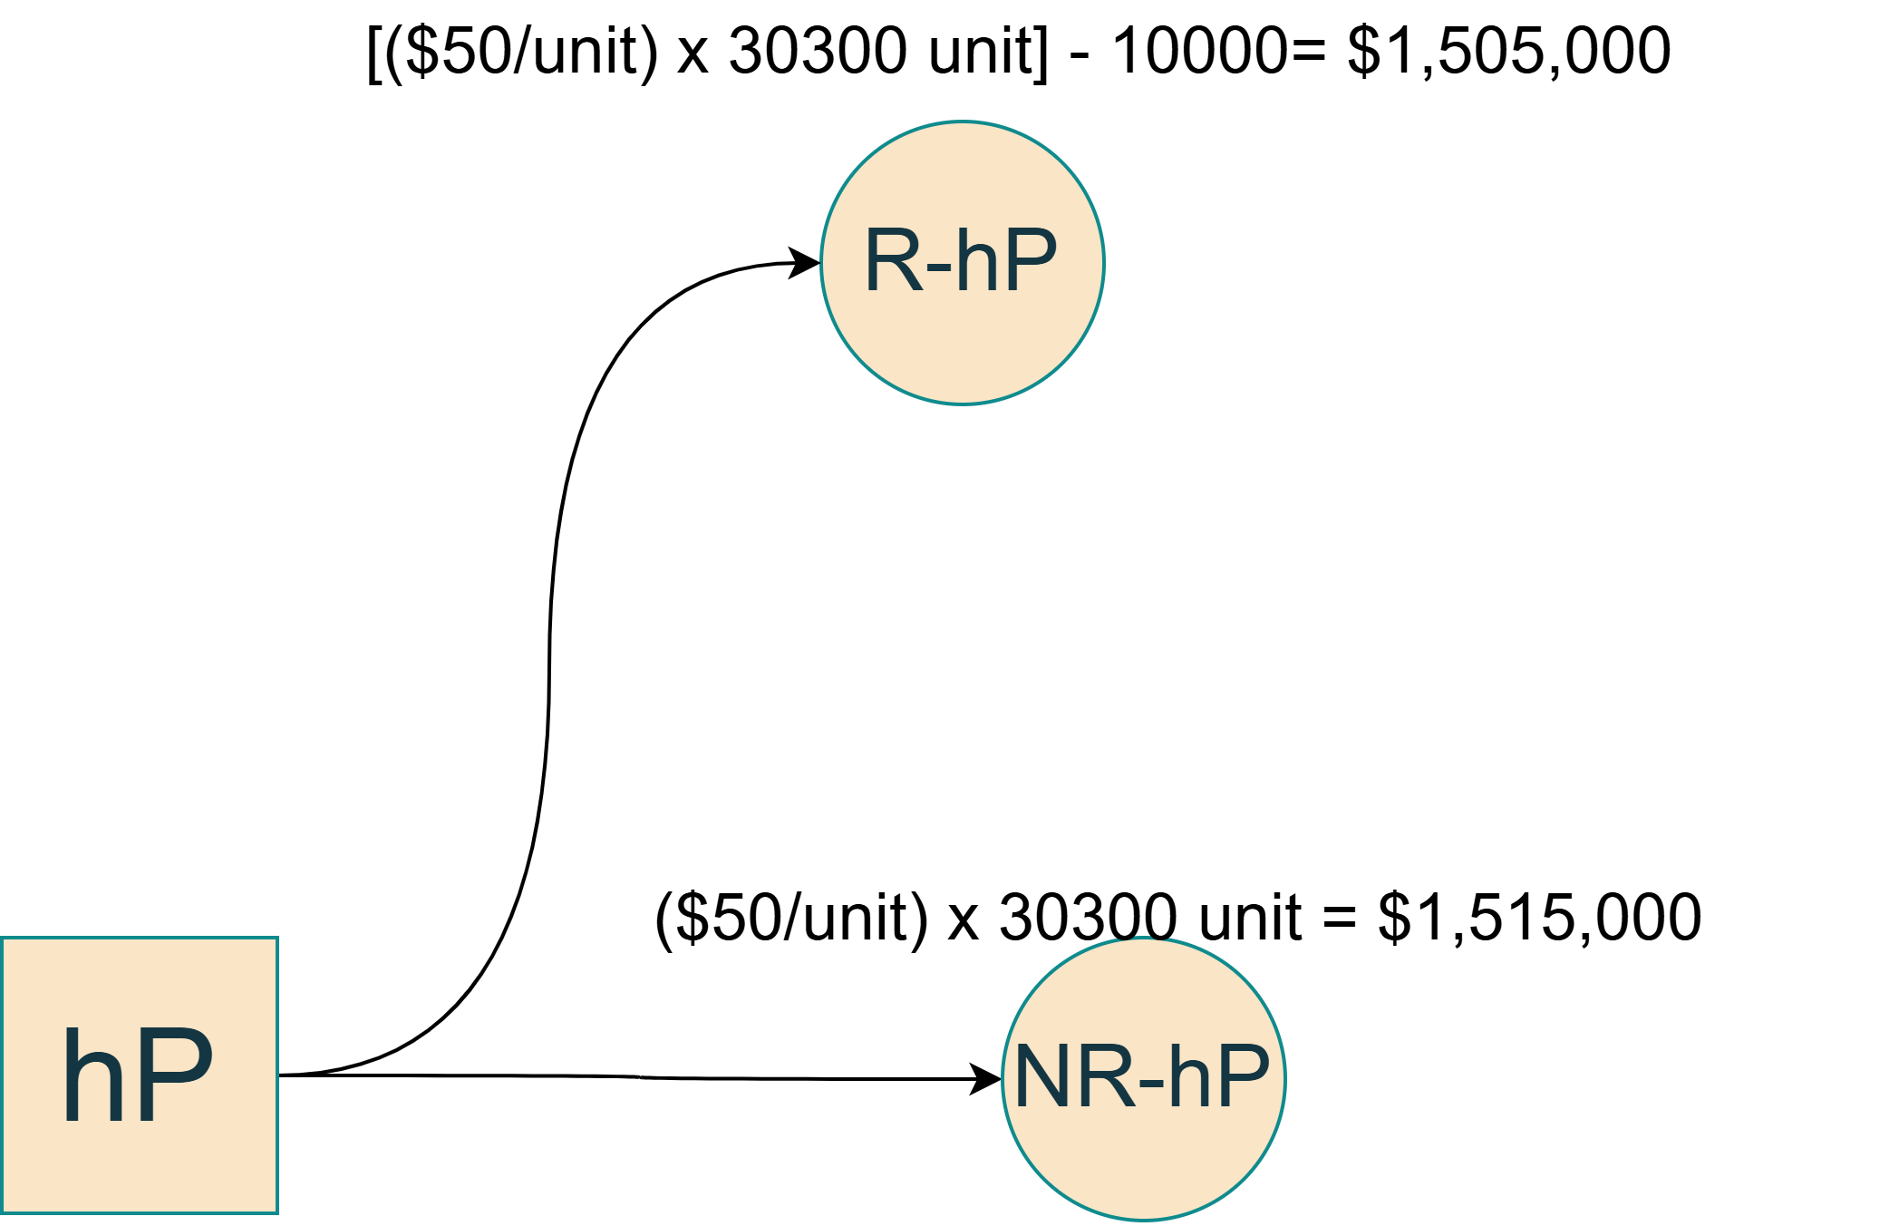

Since NR-hP have the maximum payoff.

**Charlotte should Choose to sell BrainRet at $50 per unit (hP) but NOT conduct market research.**

Decision

**Conclusion**

Based on the the Decision Tree conducted with Bayes’ Rule, the most optimal decision for Charlotte is **to sell Brainret at $50 (hP) and NOT conduct market research**. Doing so will brought forth $1,515,000 payoff. Based on the payoffs, the following should be some of the financial statements of the company:

Assuming that payoff is on a per year basis.